Configuration – Other EFS Models

Instructions for configuring other EFS models.

Gridline

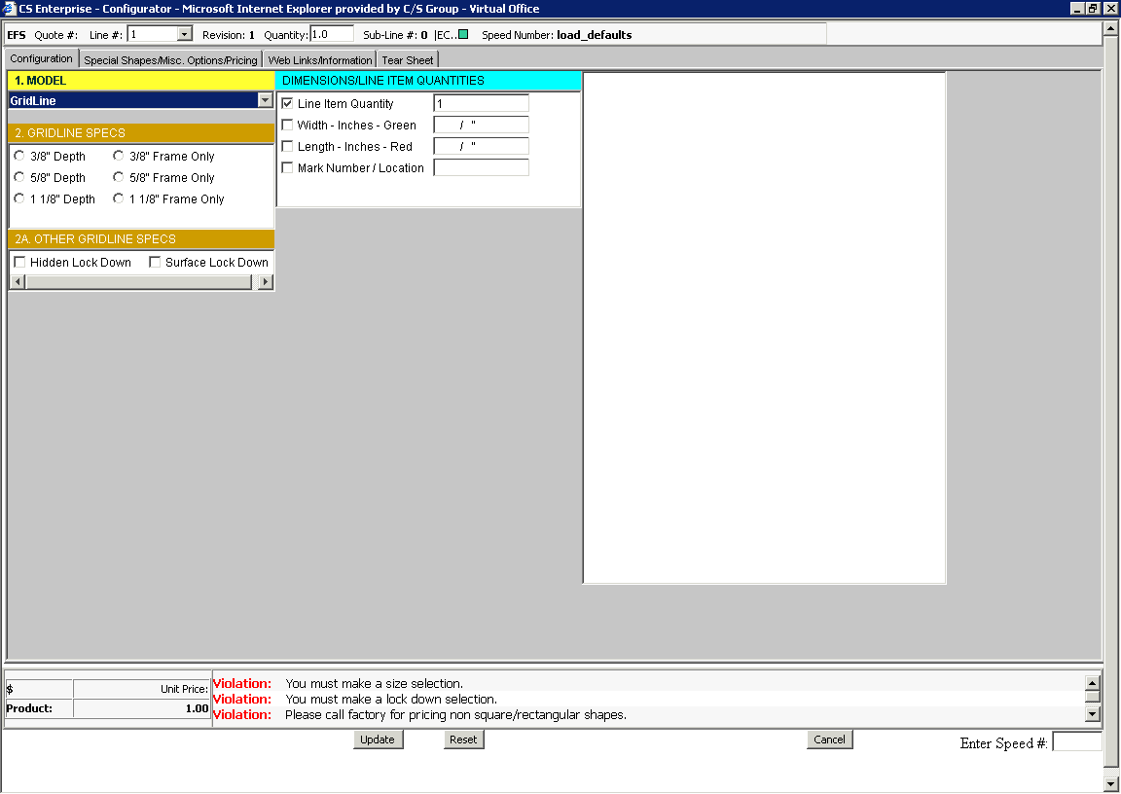

- Select “Gridline” from the #1 Model block.

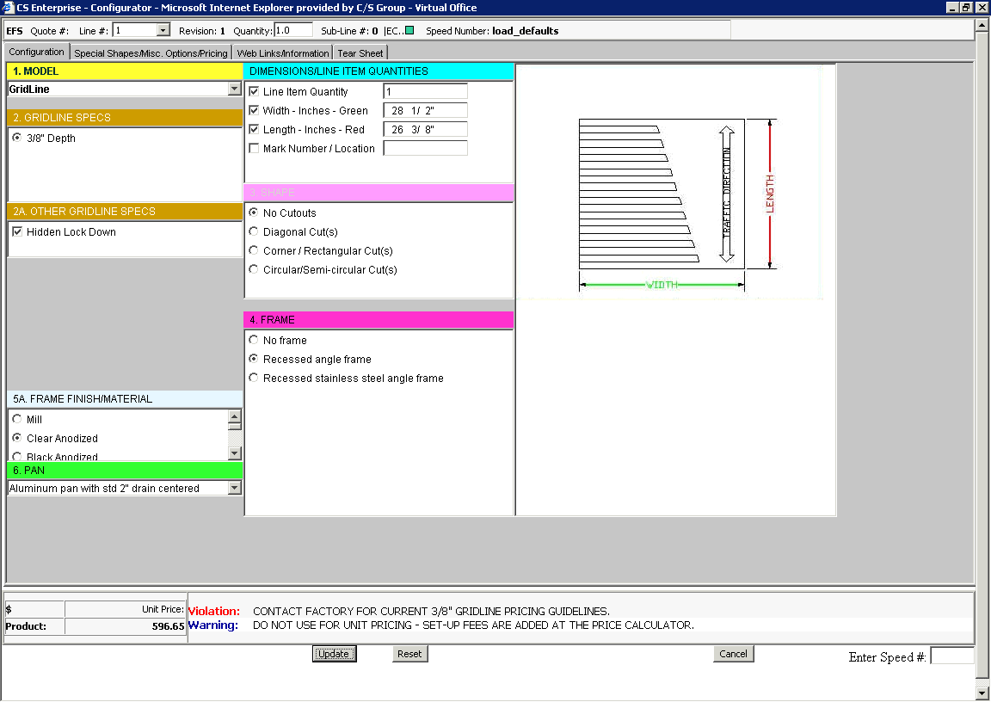
- Fill in all required fields. Note the different selections or options from the original Pedimat example in section 2.
- NOTE: Factory input is required on ALL Gridline pricing at this point in time.
- NOTE: Do not use the unit pricing option for Gridline, as additional monies are added in the price calculator for special freight.

Duromat
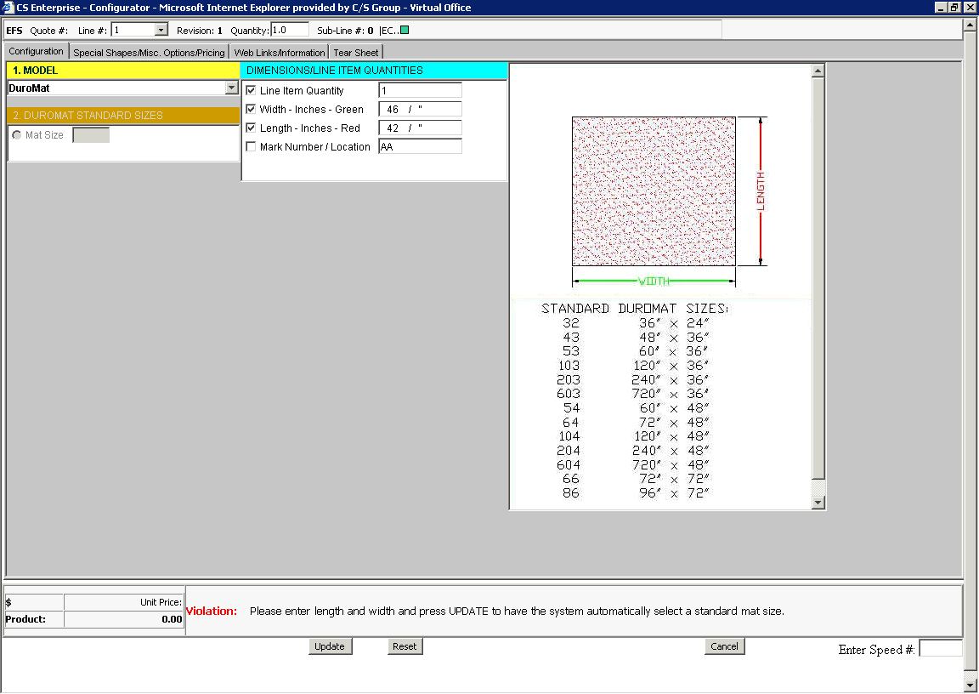

- Select “Duromat” and enter the Quantity, Width, Length and Mark Number. If the size entered isn’t one of our standard sizes, the configurator will automatically select the next larges size.
- Click on the “Update” button as the bottom center of the screen.

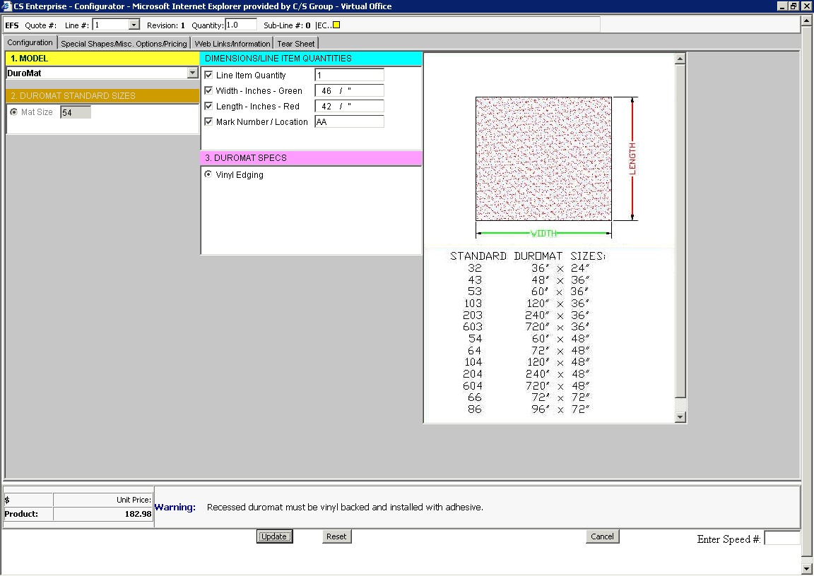
- The configurator selects the best standard size. As noted in the example the best size is the 54 standard mat which is 60” by 48”. See the gold block “2. Duromat Standard Sizes.” This is the mat that will be priced.

Design Step Entrance Carpet

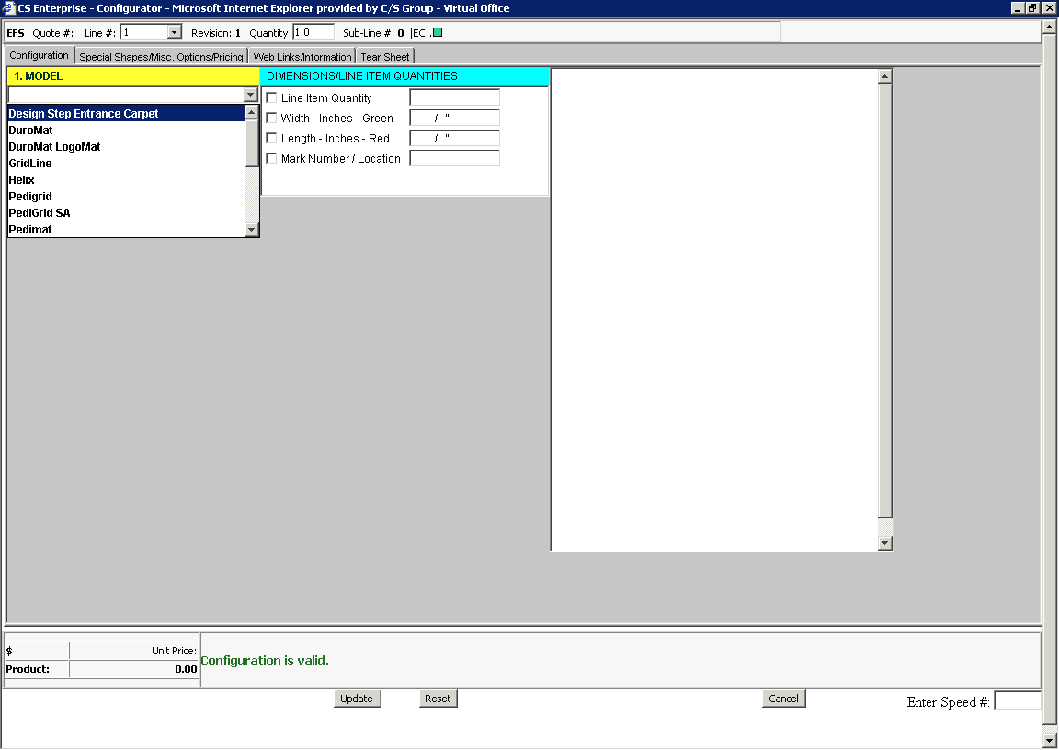

- Select “Design Step Entrance Carpet.”

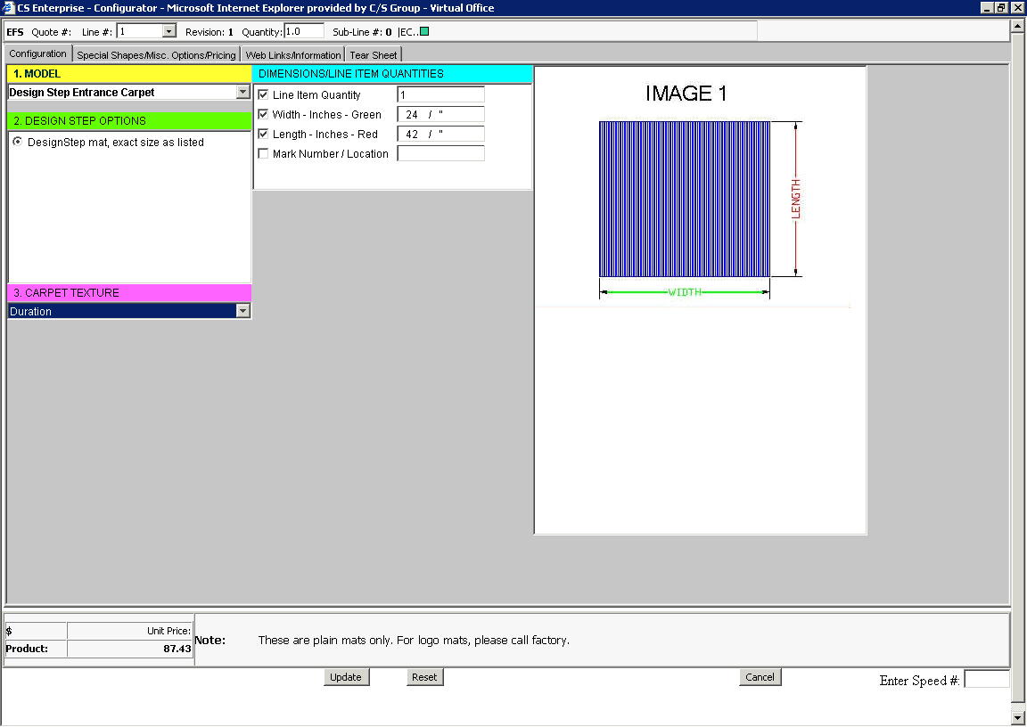
- Enter configuration information as required.
- Please note that adhesive must be ordered separately. It must be a completely separate line item. See the next page for additional adhesive instructions.
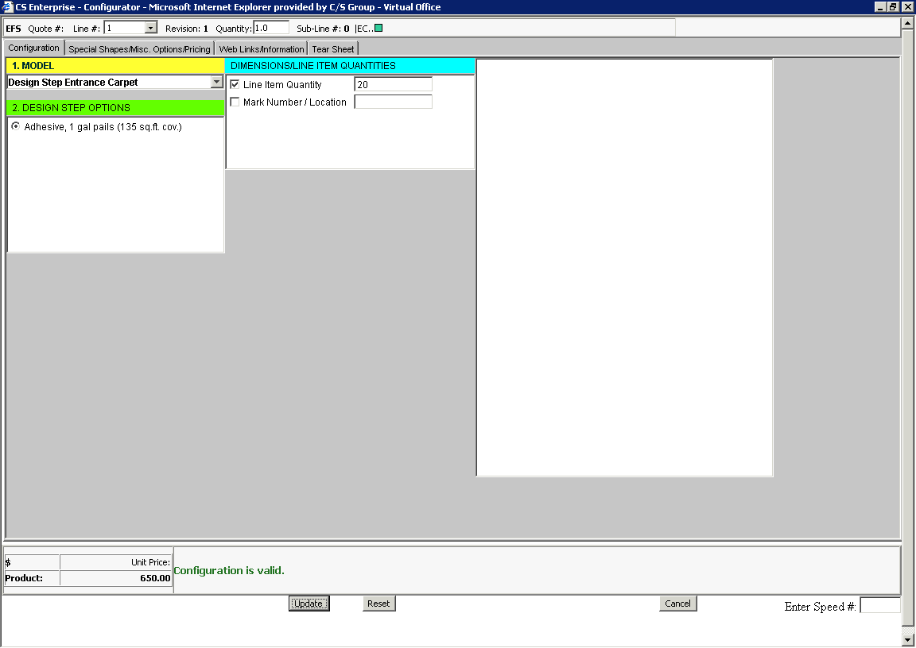
- Click on one of the Adhesive options (1 gallon or 4 gallon).
- Enter the quantity required.
- This quantity should be the total quantity required for every line item configured (entire job). Each line must be summed up manually. The quantity required for each line item is noted on the lower right hand side of each configuration.

End Section.

